Money can be used to buy goods and services.
We can pay in different ways.
Coins and notes look different and have different values.
We can sort and match coins.

Some prices are dearer than others and therefore need more money.
(Cheaper / less)
Change is given if we give more money than the cost.
We add amounts together to make a total cost.
We can make a cheaper price by taking away from the larger amount.
We are learning about Money.
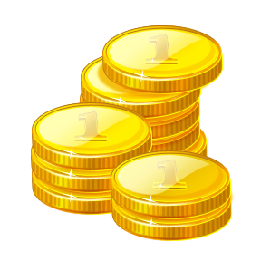
Lynda Keith Education

